**ASSIGNMENT-4**

|  |  |
| --- | --- |
| Date | 22October2022 |
| TeamID | PNT2022TMID49497 |
| Name | S Gunaseelan |
| MaximumMarks | 2Marks |

# **Question1:**

Write code and connections in work for ultrasonic sensor.Whenever distance is lessthan 100cms send"alert"toibmcloudanddisplayindevicerecentevents.

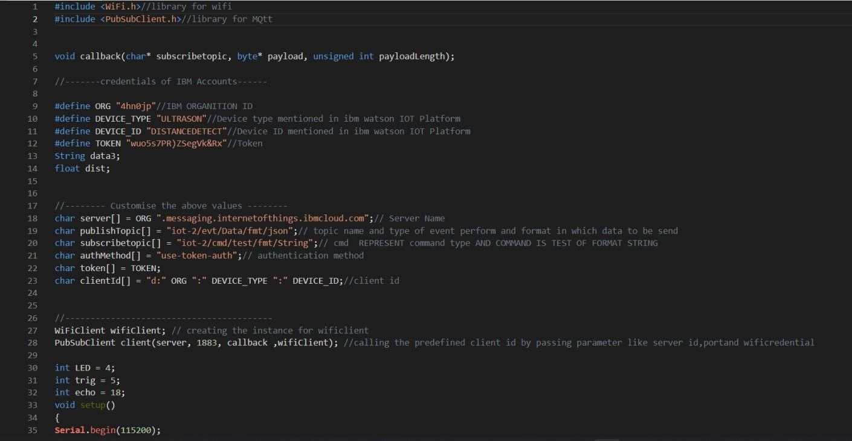**CODE**:

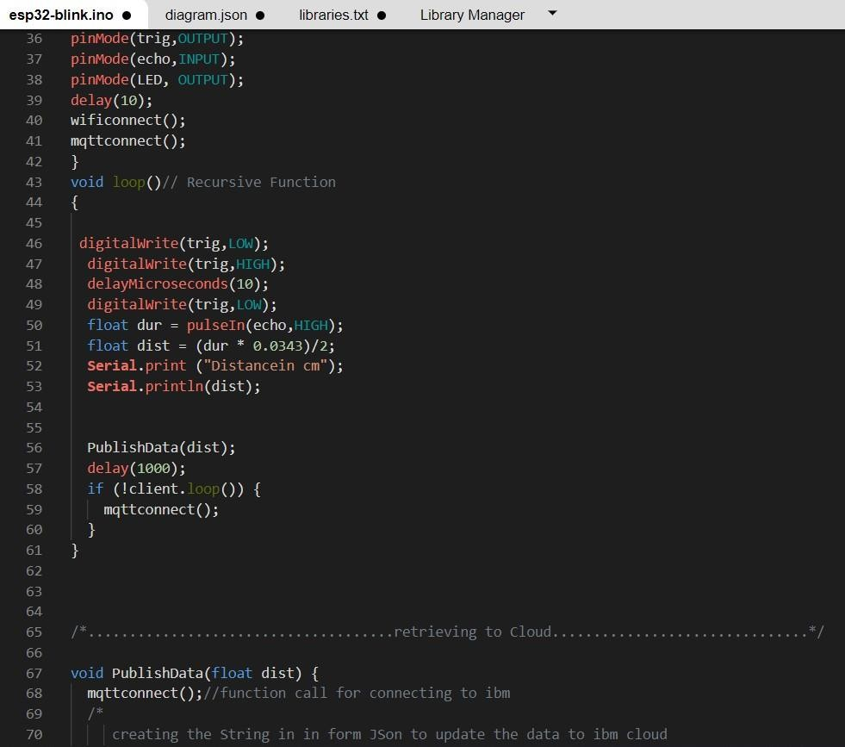

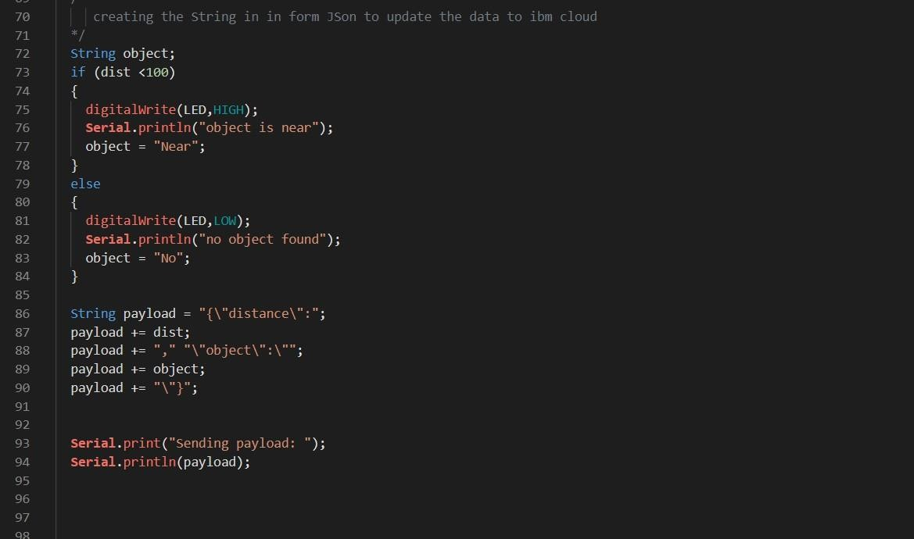

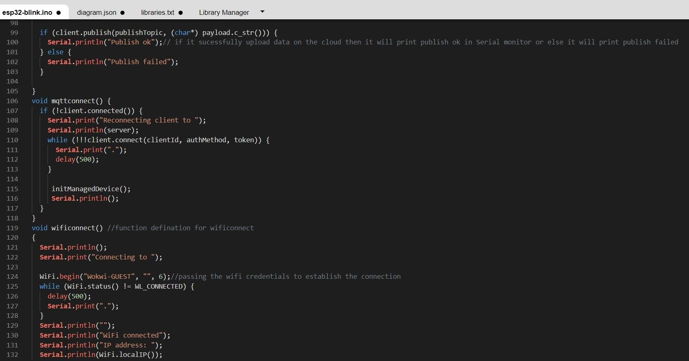

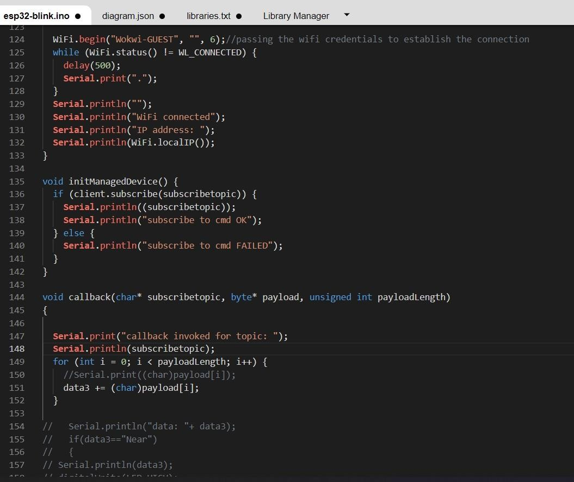

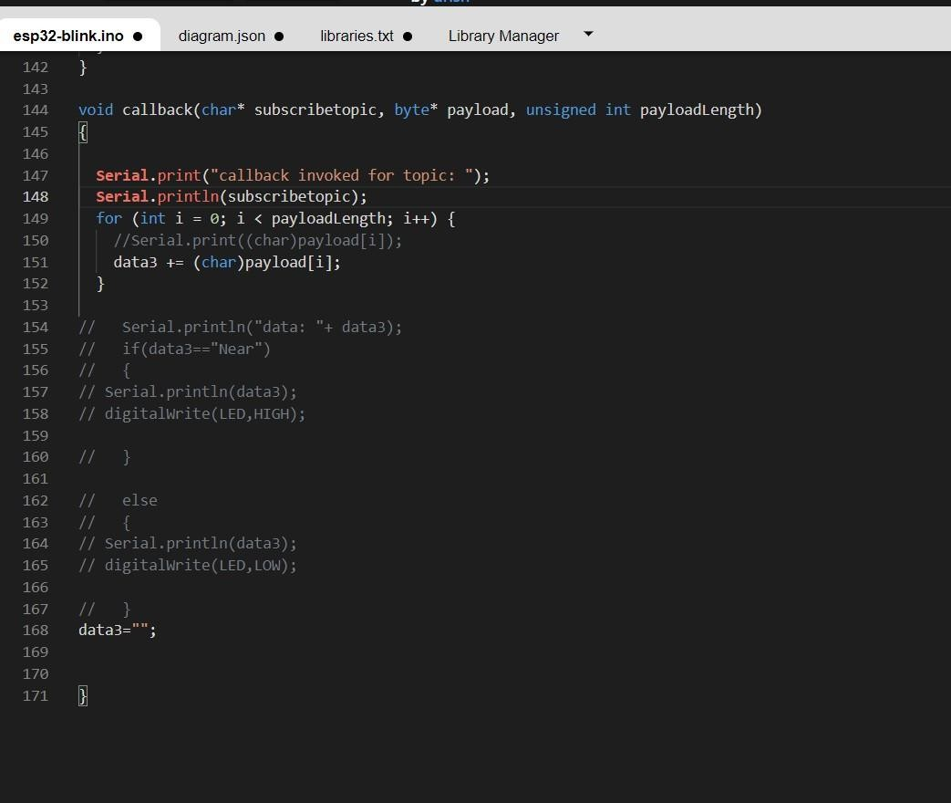

# **OUTPUT**:

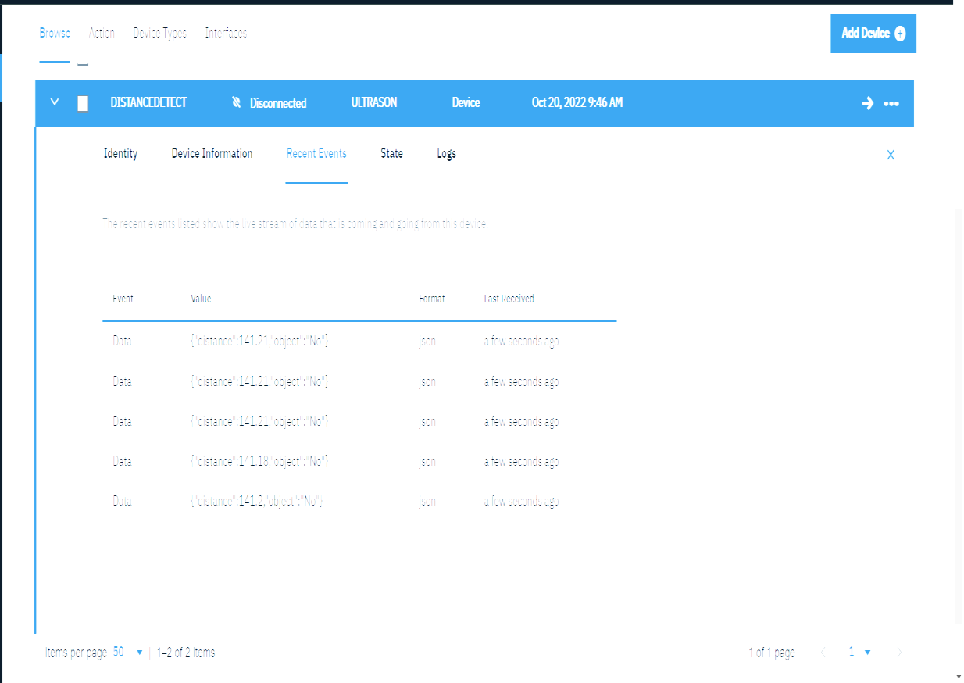DatasendtotheIBMclouddevicewhentheobjecticsfar

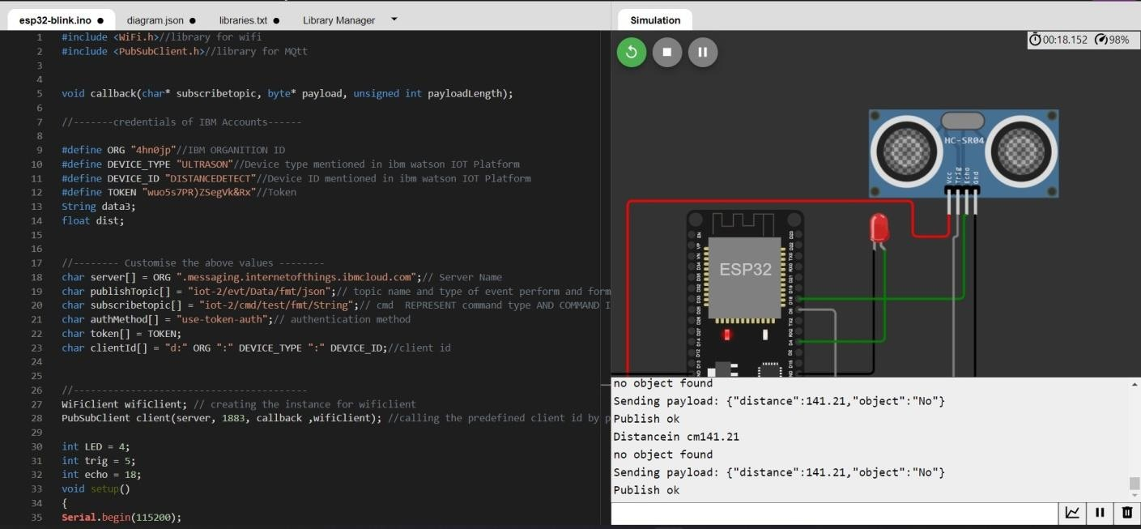

DatasenttotheIBMCloudDevicewhentheobjectisnear

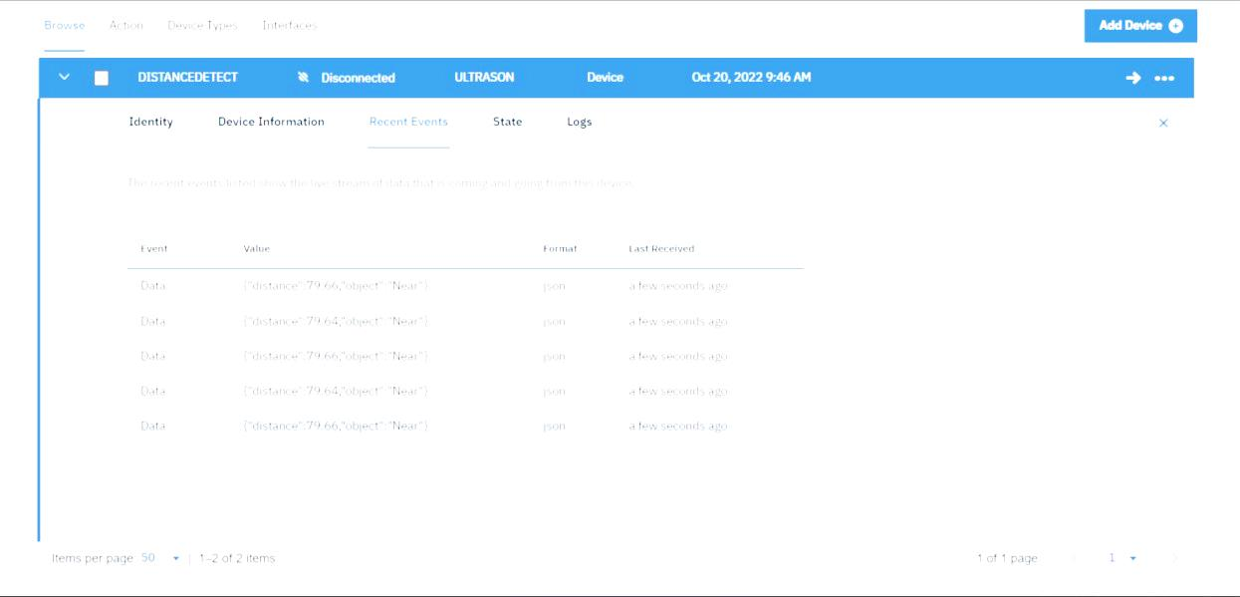­­

# 

# Whenobjecticsneartotheultrasonicsensor